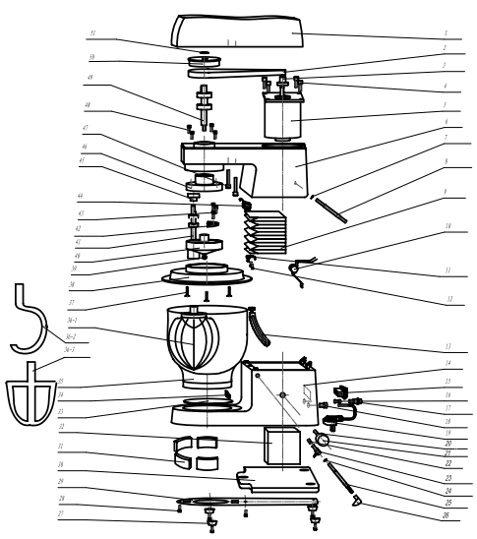

PRODUCTS EXPLODING
ITEM NUMBER | NAME | SPECIFICATION | QUANTITY
1 | Top Cover |  | 1
2 | Synchronous Belt |  | 1
3 | Small Pulleys |  | 1
4 | BOLT | HEX SOCKET  M5*22 | 4
5 | Motor |  | 1
6 | main engine |  | 1
7 | Spring block circle | ∮5 | 1
8 | Lift stem axis |  | 1
9 | shields |  | 1
10 | Big spring |  | 1
11 | Supporting frame |  | 1
12 | bolt | HEX SOCKET  M5*16 | 1
13 | Lifting lever |  | 1
14 | foundation |  | 1
15 | switch |  | 1
16 | fuse |  | 1
17 | fuse holder |  | 1
18 | fixer |  | 1
19 | electric wire |  | 1
20 | potentiometer |  | 1
21 | Speed control knob |  | 1
22 | spring |  | 1
23 | Limit knob |  | 1
24 | Spring block circle | ∮8 | 1
25 | Fixed axis |  | 1
26 | Looked knob |  | 1
27 | RUBBER LEG |  | 4
28 | bolt | HEX SOCKET  M5*16 | 6
29 | PLASTIC BOTTOM BOARD |  | 1
30 | Iron base |  | 1
31 | Small counterweight block |  | 4
32 | power |  | 1
33 | PLASTIC BOTTOM BOARD |  | 1
34 | Limit switch |  | 1
35 | Mixing barrel |  | 1
36—1 | Mixing ball |  | 1
36—2 | Mixing hook |  | 1
36--3 | Mixing pendulum |  | 1
37 | bolt | Countersunk head a word M4 * 25 | 3
38 | Protective cover | PC | 1
39 | screw nut | M8 | 1
40 | eccentric mouting | ABS | 1
41 | SHAFT group 2 |  | 1
42 | counterbalance |  | 1
43 | bolt | HEX SOCKET  M5*16 | 4
44 | Limit switch 1 |  | 1
45 | wheel | PA66 | 1
46 | Gear ring | PA66 | 1
47 | Bolt | HEX SOCKET  M5*26 | 3
48 | bolt | HEX SOCKET  M4*45 | 2
49 | SHAFT group 1 |  | 1
50 | Large pulleys | PA66 | 1
51 | Spring block circle | ∮17 | 1

